**Comsats University Islamabad**

**Abbottabad Campus**

***Information Security***

***Lab Task 2a***

**Name:** Malik Obaid Ur Rehman

**Reg no:** FA23-BCS-055

**Instructor:** Ma’am Fatime Hameed

**Activity 1 Accept two lists from user and display their join.**

print("Enter 4 values for list one : ")

list1=[]

for i in range(0,4):

    list1.append((input()))

list2=[]

for i in range(0,4):

    list2.append((input("Enter 4 values for list two : ")))

print(f"appended list 1 and list 2 is : {list1+list2}")

Output:

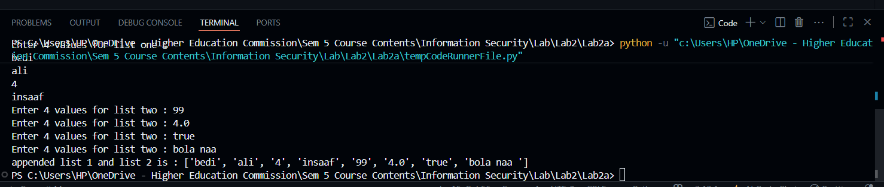

**Activity 2:** A palindrome is a string which is same read forward or backwards. For example: "dad" is the same in forward or reverse direction. Another example is "aibohphobia" which literally means, an irritable fear of palindromes. Write a function in python that receives a string and returns True if that string is a palindrome and False otherwise. Remember that difference between upper and lower case characters are ignored during this determination.

def palindrome(word):

    return word == word[::-1]

print(palindrome("madam"))

**Activity 3:**

magine two matrices given in the form of 2D lists as under; a = [[1, 0, 0], [0, 1, 0], [0, 0, 1] ] b = [[1, 2, 3], [4, 5, 6], [7, 8, 9] ] Write a python code that finds another matrix/2D list that is a product of and b, i.e., C=a*b

list1=[[12,34,23],

       [3,5,4],

       [87,73,32]]

list2=[[12,343,43],

       [3,5,5],

       [1,4,2]]

list3=[[],[],[]]

for i in range(len(list1)):

    for j in range(len(list1[i])):

        list3[i].append(list1[i][j]*list2[i][j])

print(list3)

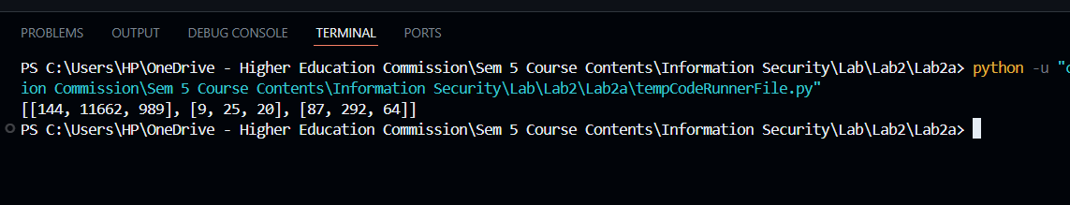

**Lab Task 1:**

Create two lists based on the user values. Merge both the lists and display in sorted order. A if marks

list1=[]

list2=[]

for i in range(0,4):

    list1.append(int((input("Enter 4 values for list one : "))))

for i in range(0,4):

    list2.append(int((input("Enter 4 values for list two : "))))

print(list1)

print(list2)

list3=list1+list2

list3.sort()

print(f"appended list 1 and list 2 in sorted order  is : {list3}")

**Lab Task 2:**

Repeat the above activity to find the smallest and largest element of the list. (Suppose all the elements are integer values)

list=[1,45,25,78,34,23,90,11,10]

# using builtin methods

print(f"max value in the list is : {max(list)}")

print(f"min value in the list is : {min(list)}")

# without using builtin methods

max=list[0]

min=list[0]

for i in list:

    if i>max:

        max=i

    if i<min:

        min=i

print(f"max value in the list is : {max}")

print(f"min value in the list is : {min}")

